Дата: 02.06.2022 Клас: 6-Б

Предмет : Англійська мова

Тема: Повторення за 2 семестр.

Мета: узагальнити та систематизувати знання, уміння та навички з тем «Країни та їхні столиці», «Лондон»; повторити правила уживання означеного та неозначеного артиклів, Present Simple,Past Simple та Present Perfect; розвивати навички читання; вживання граматичних структур в усному та писемному мовленні; сприяти формуванню комунікативної компетенції.

Вчитель: Глуговська Л.Г.

**Хід уроку**

***1.Greeting***

Good afternoon, dear children! I’m glad to see you. Are you ready to start our lesson? Let’s start.

1. ***Speaking***

*Дайте відповіді на питання.*

Ex.10 page 185

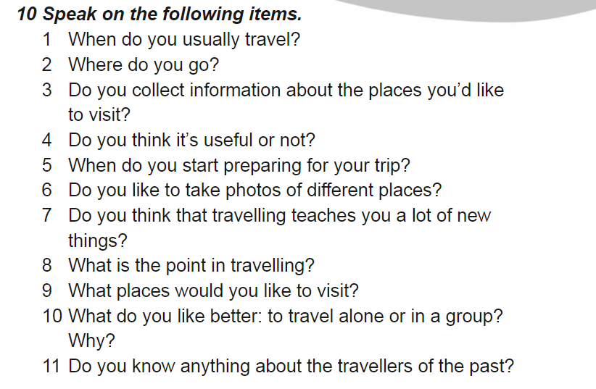

1. ***Grammar***

Повторюємо граматичні часи, розкрийте дужки та оберіть правильний варіант(усно).

**Open the brackets and put the correct tense form of the verb (Future Simple, Present Continuous, Past Simple)**

1. Tom ___ (not to eat) breakfast yesterday.
2. won’t eat b. doesn’t eat c. didn’t eat
3. His father __ (not to watch) TV at the moment.
4. am not watching b. aren’t watching c. isn’t watching
5. Where _ she __ (to be) tomorrow?
6. Will she be b. has she been c. is she
7. He __ (not to go) to the south a week ago.
8. didn’t went b. didn’t go c. didn’t goed
9. She __ (to enjoy) listening to his songs last night.
10. enjoyed b. has enjoyed c. enjoyes
11. Tom __ (to travel) around the world next year.
12. travels b. will travel c. has traveled
13. I __ (to be) very busy last summer.
14. was b. were c. been
15. I __ (to go) to bed at ten o’clock tomorrow.
16. went b. go c. will go
17. When _ you __ (to leave) home for school tomorrow?
18. are you leaving b. will you leave c. did you leave
19. Look! The baby __ (to sleep).
20. am sleeping b. is sleeping c. are sleeping
21. __ he __ (to play) now?
22. Did he play b. Is he playing c. Will he sleep
23. __ granny _ (to cook) dinner now?
24. Is granny cooking b. Did granny cook c. Will granny cook
25. ***Scrambled questions***

Put the words in the logical order to make up the questions and answer them.

Є п’ять речень із розкиданих слів. Потрібно правильно побудувати питання та дати на нього відповідь.

1. Is / main / what / the / national / holiday / Ukraine / in? — What is the main national holiday in Ukraine? (Independence Day)

2. The / what / official / is / in / country / our / state / language? — What is the official state language in our country? (Ukrainian)

3. What / does / border / on / Ukraine / countries? — What countries does Ukraine border on? (Ukraine borders on Poland, Hungary, ...)

4. Population / Ukraine / of / the / is / what? — What is the population of Ukraine? (More than 39 million)

5. Ukraine / river / is / the / main / what / in? — What is the main river in Ukraine? (Dnieper)

6. Situated / where / Ukraine / is? — Where is Ukraine situated? (In the centre of Europe)

***5. Reading***

*The Houses of Parliament*

Its official name is the Palace of Westminster. Most of the building was built in 1840 after a fire in 1834 destroyed the old palace. At the north end of the building by Westminster Bridge is the famous clock tower, Big Ben.

*The National History Museum*

Situated in Kensington. One of London’s greatest museums. A huge collection of animals and plants, including a quarter of a million butterflies, a blue whale and the famous dinosaur skeletons. Cafeteria, gift shop and book shop. Open daily 10 — 5.45.

*Madame Tussaud's Museum*

This famous waxworks has models of famous people from pop stars to prime ministers. Displays of battles and Chamber of Horrors. Gift shop.

Open every day 10 — 5.30, except Christmas Day.

***6.Writing***

Thursday, the second of June

Homework

**Розкрийте дужки та поставте дієслово у Present Perfect**

**Open the brackets and form Present Perfect:**

1. We _____ (already to learn) a lot of English words.
2. The boy __ ( not to do) his homework yet.
3. He __ (already to learn) the rule.
4. I __ (not to eat) yet.
5. I __ (not to see) him since 1987.
6. You __ (to book) tickets? – Yes, I __

***7. Homework***

Домашнє завдання:

1. Виконати вправу з розділу ***Writing*** ***(письмово)***
2. Опрацювати матеріал конспекту.

**Надіслати виконану вправу у Вайбер (0964124047) – Людмила Григорівна або прикріпити на Human.**